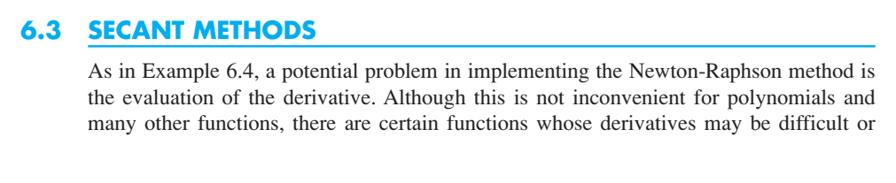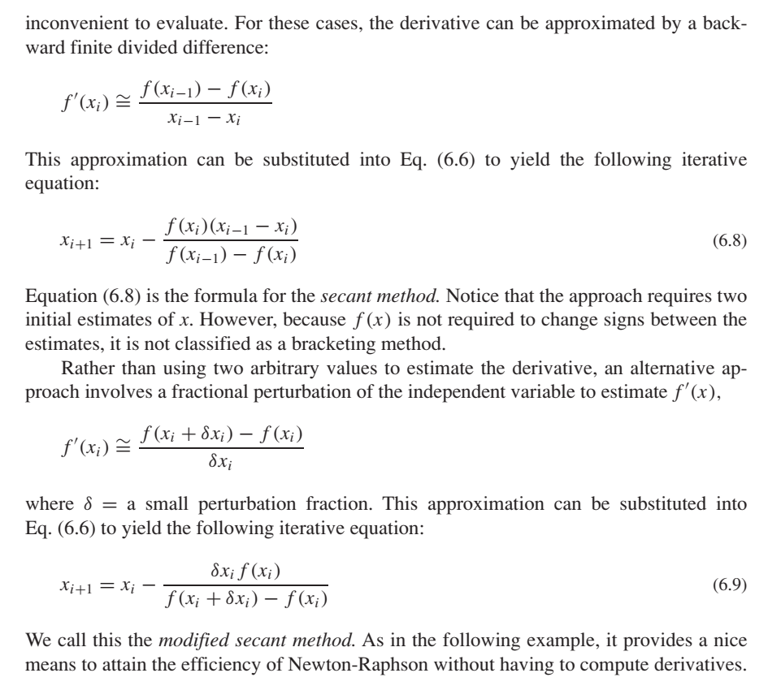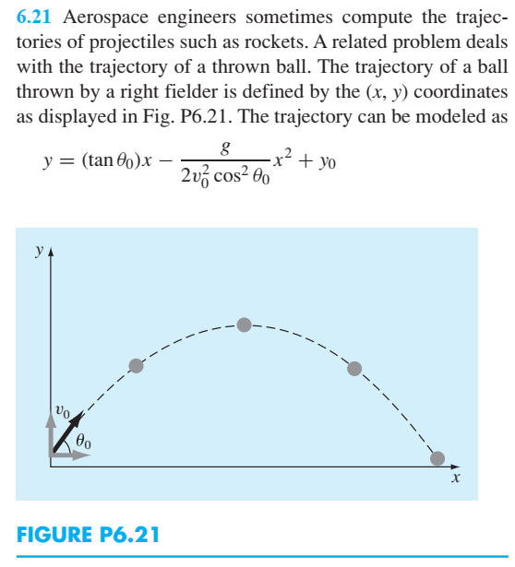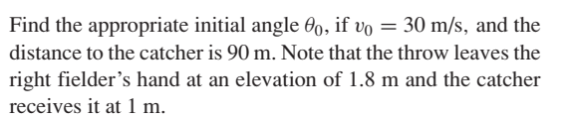

Solve the problem using secant method and compare it with newton Raphson method. Draw appropriate graphs as required

